**ACTIVE TRANSPORT TO SCHOOL: IDEALS AND REALITIES**

*By Elaine Mullan, MA, PhD, and Jean Lodge, B.A. (Hons)*

**Summary**

*Rates of cycling and walking to school, or active transport to school (ATS) have been in decline, in Ireland and across the ‘developed’ world, since the mid 1980’s. In particular, very few now cycle to school. At the same time, rates of childhood obesity have been rising. Also, many young people today do not get sufficient daily physical activity to benefit their health. Research with students, parents and teachers in a girls’ secondary school in co. Waterford over a nine-month period confirmed that road safety fears and lack of suitable infrastructure (e.g., bike paths, pedestrian crossings) are the most common reasons for lack of ATS. Increasing car use generates the traffic volumes that increases fear of road traffic accidents. This restricts young people’s independent travel, means less people in general walk and cycle, creates a greater social pressure to drive everywhere and creates greater fear of ‘strangers’. This leads to more parents chauffering their children from A to B, which, in turn, increases traffic volumes and fear of accidents. The case study also found that no girl cycled to school in Tramore and that attitudes to cycling were particularly negative. The girls’ greatest barrier to ATS in general was their perceived image. ATS was seen as awkward, dangerous, requiring effort, creating hassle and sweat. Car travel was seen as safer, more pleasant, less hassle, and didn’t ruin their ‘look’.*

**Introduction**

The childhood and adolescent years are generally considered as a time of energy, exploration, activity, sociability and discovery. Yet many young people today live their lives confined by their and their parents’ fears of traffic and strangers to bedrooms, schoolrooms and select venues to which they are transported to and from by their parents. They are not allowed to cycle or walk to school, to go places on their own and, increasingly, not allowed to play or ‘hang around’ outside. There are obvious negative effects on their weight and physical fitness, but the more insidious, and potentially more harmful effects on their emotional and social health are typically overlooked in the haste to keep them ‘safe’.

This chapter will consider some of the factors that influence levels of active transport among young people and the factors that lie behind the restrictions placed on their independent travel, such as attitudes to walking and cycling, car dependency and the physical design of neighbourhoods. We also present a case study of an active transport to school scheme in a girls secondary school in Co. Waterford, during which we examined attitudes towards active transport to school. This gives an insight into adolescent girls’ attitudes to walking and cycling.

**Safe Routes to School?**

Cycling or walking, all or part of the way, to and from school, five days per week, provides an excellent opportunity for the accumulation of health-enhancing physical activity. Those who actively commute to school also engage in more total physical activity than those who travel by car or public transport (Cooper, Page, Foster & Qahwaji, 2003; Tudor-Locke, Ainsworth, Adair & Popkin, 2003; Alexander, Inchley, Todd, Currie, Cooper & Currie, 2005). Most pupils in Ireland live within 6km of their school, a very manageable cycling distance for a healthy adolescent and shorter distances are easily walked. However, data from the Central Statistics Office show a clear decline in the percentages who walk or cycle to school over the last two decades. In 1981, 30% of 13 – 18yr olds walked to school but in 2002 only 26% did. A far bigger decline is seen in the numbers cycling: from around 13% in both 1981 and 1991 to 3% in 2002.

A recent survey of 147,000 primary and secondary school children in the Greater Dublin Area (GDA, comprising Dublin, Wicklow, Kildare and Meath: Dublin Transport Office, 2007) found an increase of 9% in the numbers of secondary school pupils in the region travelling to school by car between 2002 and 2006 (22% in 2002, and 31% in 2006). Sixty per cent of these students live less than three kilometres (1.8 miles) from their school. Numbers of secondary school pupils cycling decreased between 2002 and 2006, from 6% to 5%, numbers walking decreased from 37% to 34%, and numbers using public transport decreased from 34% to 29%. These numbers are confirmed by the Dublin city and county based ‘Take PART’ study (Physical Activity Research in Teenagers: Nelson, Foley, O'Gorman, Moyna and Woods, 2008), which found that almost 29% of the 4013 participants came by car, 32% walked and 5% regularly cycled to school between 2003 and 2005. Almost ten times more boys (9.4%) than girls (1%) cycled. The majority of walkers and cyclists lived within1.5 or 2.5 miles of school, respectively. The likelihood of active travel to school decreased with each extra mile of distance to school, and over 90% of those who lived further than 2.5 miles from school cited distance as a barrier to active commuting (Nelson et al. 2008).

Figure 1 shows that 40% of all travel to education in the GDA is now by car, an overall 6% increase since 2002. This trend is also evident across the ‘developed’ world in general (Roberts, Carlin, Bennett, Bergstrom, et al. 1997), in the UK (Cooper, Page, Foster, Qahwaji, 2003), Australia (Carlin, Stephenson, Roberts, Bennett, Gelman & Nolan, 1997; Morris, Wang & Lilja, 2001) and the US (Sirard, Ainsworth, MsIver & Pate, 2005).



Figure 1. Mode of travel to education – 2002 Vs 2006 (DTO, 2007)

This trend has depressing implication for rates of traffic congestion in our towns and cities in the years to come, when these young chauffeured school-goers become car-dependant adults. An examination of adult Dublin car drivers’ and cyclists’ decision to cycle or not to cycle by Galbraith & Keegan (2005) found that cycling patterns in early life had a strong influence on travel behaviour in later life. A significantly higher proportion of cyclists had previously cycled to either secondary school and/or to college ‘all of the time’ or ‘most of the time’ (47% or 57%) compared with ‘car commuters’ (25% or 16%). Galbraith and Keegan conclude that encouraging ATS among the school going age groups appears to be very important in maintaining or increasing the amount of adults who regularly cycle for transport.

**Safety**

Road safety, or lack thereof, is one of the main reasons cited by parents and children for driving to school. On their route to school children and young people cite fears of the high speed of cars, high traffic density, drivers who don't stop at zebra crossings, cars parked on pedestrian and cycle paths and also the lack of safe crossings (Timperio, Ball, Salmon, Roberts, Giles-Corti, Simmons, Baur, and Crawford, 2006). Parental perceptions of the need to cross several roads and the lack of traffic lights or crossings are negatively associated with children regularly walking or cycling to school (Timperio, Crawford, Telford & Salmon, 2004). Di Guisseppi, Roberts and Li (1997) found, in the London boroughs of Camden and Islington, that 90% of the parents surveyed were worried about their child being abducted and 86% were worried about traffic danger. Children who report that their parents are worried about abduction/molestation or traffic danger, and who do not allow them go out without an adult, are more likely than others to be driven to school (Evenson, Huston, McMillen, Bors & Ward, 2003). The DTO’s (2007) survey of transport to education in the GDA found that the main reason stated for not walking to school in both primary and secondary schools was that it was ‘too far’ –this is despite 60% living under 3km from their school.

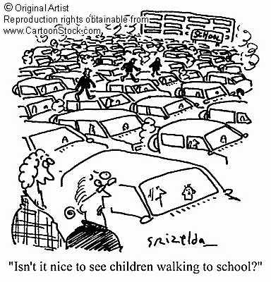

The cruel irony in all of this is that driving children to school makes it more dangerous for other children to walk to school, creating a self-reinforcing spiral of ever-increasing car-dependence, as illustrated in Fig 2. Parents typically taxi their off-spring to their various destinations, instead of encouraging them to walk or cycle there, as they believe they are minimising the risk of traffic-related injury. In fact, the increased car use that this generates increases traffic volume, which, in turn, increases the risk of traffic-related injury for all road users, including car drivers and passengers. So parents, in turn, try to improve the safety of their vehicle, hence the proliferation of SUV-type vehicles and front bumper bull-bars - both increase the risk of traffic-related injuries to pedestrians and cyclists and increase the perception that walking and cycling are dangerous.



Figure 2. The school journey and the vicious circle of increasing motorized traffic (Sustrans, 1996, as cited in Davies, 2003)

In England in 1971, 80% of seven and eight year olds made the journey to school unaccompanied by an adult (Hillman,1993; Dixey, 1998) - the figure doing so in Ireland then was undoubtedly similar, if not greater, but it is now less than 10%. Much of this trend can be accounted for by increased parental fears for their children’s safety on the roads due to increased traffic volumes, which has led to the imposition of more vigorous restrictions on activities such as bike-riding, walking and street play (Hillman,1993; Dixey, 1998). Vanderbeck & Johnson (2000) found that children themselves believed safe play and independent mobility were all but impossible due to congestion, the absence of bicycle routes, a shortage of play spaces and a fear of crime. Not surprisingly, children generally agreed with their parents that their leisure time was best spent indoors (either at home or at a shopping centre) and that adults should accompany them on most journeys (Vanderbeck & Johnson, 2000)

# Fear and Freedom

Most adults consider their car as a welcome addition to their life that immensely improves its quality, and believe it is a safer way to transport their children. However, it is important to consider how the increased freedom and convenience that cars have afforded adults may have a negative impact on young people’s quality of life. Hillman (2000) highlights many that are overlooked: less people out and about on the street and far fewer adults about to supervise play activities; less frequented areas becoming ‘no-go’ areas; greater levels of traffic and streets increasingly dangerous places for play, informal sports, cycling and walking; greater fear of traffic. He concludes that young people’s lives have become far more confined and restricted that those of their parents’ generation.

*“This generation of children are far less likely to be able to learn how to make decisions when on their own, how to act responsibly and how to assess the motives of those they do not know. They are less likely to be able to have adventures, extend personal frontiers, be mischievous, learn directly the consequences of being careless, gain self-esteem and self-confidence from acting sensibly and contribute to family and community life by shopping, visiting or running errands for old people. These are all essential elements of becoming responsible citizens”* Hillman (2000. p. 1).

Davis and Jones (1997) describe a state of ‘traffic-induced social exclusion’ as a situation wherein young people are increasingly spending greater amounts of time indoors because of their and their parents’ fears of ‘stranger-danger’ and road traffic accidents. This leads to increased fear and worry, journeys foregone, restricted independent mobility, and reduced social and play activities outside of the home, school and playground (Dixey, 1998). Research published in 2003 by Britain's National Children's Bureau found that 67 per cent of eight to 10-year-olds and 24 per cent of 11 to 15-year-olds had never been to the park or the shops on their own. The erosion in child autonomy has great consequences for young people’s physical and social health, and quality of life.

**Neighbourhood Design And Active Transport**

The rapid expansion of Irish towns and their residential areas in recent decades seems to have been planned, implicitly, on the basis that walking and cycling will not be required in the future and, therefore, are not to be encouraged. Yet, it is generally accepted that neighbourhood design and/or local area planning has an important affect on physical activity levels (including walking and cycling for transport) that is independent of age, gender, socio-economic status and other individual-based factors (Saelens, Sallis, Black & Chen, 2003).

The decision to use the car or ask for a lift, or walk/cycle is based primarily on proximity (distance to travel) and connectivity (directness of travel: Frank, 2000). Other factors such as travel costs, environmental quality, aspects of convenience and access to parking are also likely to be influential (Saelens, Sallis & Frank, 2003). Planners often label neighbourhoods “pedestrian-orientated” if they have relatively high densities of development, a mix of land uses, a street network with high connectivity, human-scale streets, and desirable aesthetic qualities in that they make walking more viable and more appealing (Handy et al, 2002). These factors also have a big impact on levels of physical activity (Duncan et al., 2005; Hume, Salmon and Ball, 2005; Saelens et al., 2003; TRB/IOM, 2005) and on the likelihood and prevalence of obesity and overweight (Catlin, Simoes, Brownson, 2003; see review in Booth, Pinkston & Poston, 2005).

Proximity is affected by two additional factors density and land use mix (Saelens et al., 2003). Density is defined as population, employment or building square footage per unit of area and may be measured as people per acre or jobs per square mile. Population density is among the most consistent positive correlates of walking trips (Frank & Pivo, 1994; Cervero, 1996). Land use mix refers to the relative proximity of different land uses within a given area, such as residential, commercial or sport (Saelens et al., 2003). A high mixed-use neighbourhood would include not just houses but also shops, offices and parks. Much modern development is based on single use with land uses widely separated resulting in a lack of land use mix (Saelens et al., 2003). In modern suburbs it is typically impossible to walk from one’s home to the nearest shopping centre or place of employment. High mixed use, particularly the close proximity of shopping work and other non-residential land use to housing, appears to be related to greater walking and cycling among residents (Saelens et al., 2003)

While most of this research has been carried out with adults, several recent studies with young people have found that neighbourhood design, availability of facilities and perceptions of the neighbourhood were related to physical activity (Timperio, Crawford, Telford & Salmon, 2004; Krizek, Birnbaum & levenson, 2004; Gordon-Larsen, Nelson, Page and Popkin, 2006). Young people are more active and use more active forms of transport when there are fewer roads to cross, footpaths, less traffic, regular public transport, and distances are relatively short to places they want to go (Krahnstoever-Davison & Lawson, 2006). Therefore, the road system, zoning practices, and the extent to which young people can go places on their own all influence their physical activity experiences (Churchman, 2003). This highlights the clear link between local area planning and the likelihood of active travel.

**Research in Ireland**

There is a substantial deficit of research in Ireland into the barriers to and facilitators of active transportation to school, and a lack of exploration of the attitudes of parents, pupils and teachers towards active transportation to school. To date, there have been only two research-based pilot projects, both carried out in large urban areas. The first of these, run by the Dublin Transport Office (O’Driscoll, 2005), examined the effectiveness of making infrastructural changes to the surrounding neighbourhood: the GDA-based Safer Routes to School pilot project, 2000 – 2002. The study focused primarily on improving footpaths and adding traffic calming measures, pedestrian crossings and cycle lanes, in the vicinity of six primary schools, at a cost of almost €1.66m. The main findings were that the provision of infrastructure alone did not change travel patterns. Only when schools were actively involved and encouraged did a shift in travel patterns occur. The participation of key community stakeholders, including An Garda Siochána, and having a local ‘champion’ for the cause were found to be essential (O’Driscoll, 2005).

The second research-based pilot project, the Green-Schools Travel Pilot Programme to promote active travel to school, ran from August 2005 to 2007, and involved 29 primary and secondary schools in the GDA (www.greenschoolsireland.org). They found an increase in cycling across all schools from 2.5% - 5%, an increase in walking by 9% and a decline in car use by 11% – 12%. However, a full report has yet to be published.

**Case study: a school travel plan scheme**

The following section outlines some exploratory research with two aims:

1. To explore attitudes concerning active transport to school (ATS) of students, teachers and parents, before during and after the process of implementing a *School Travel Plan* (STP) with particular focus on exploring the reasons why so few teenage girls in particular, cycle and walk to school.
2. To evaluate the impact of the STP on attitudes to ATS and patterns of travel to school over a six month period.

A School Travel Plan (STP) is a written document, developed by students in consultation and co-operation with staff, parents and other stakeholders, that outlines guidelines or ‘regulations’ that are aimed at encouraging walking and biking to school. In this research, the development, implementation and evaluation of the STP provided a context around which to explore attitudes to ATS.

The research was undertaken with the pupils, staff and parents of pupils of Stella Maris girl’s secondary school in Tramore, Co. Waterford. Tramore is a coastal town, with a population of 8305 within the town centre and 7764 within its electoral area (27% and 25% increase on 1996 figures respectively). It is a major tourist town in the region and also serves as a dormitory town to neighbouring Waterford City.

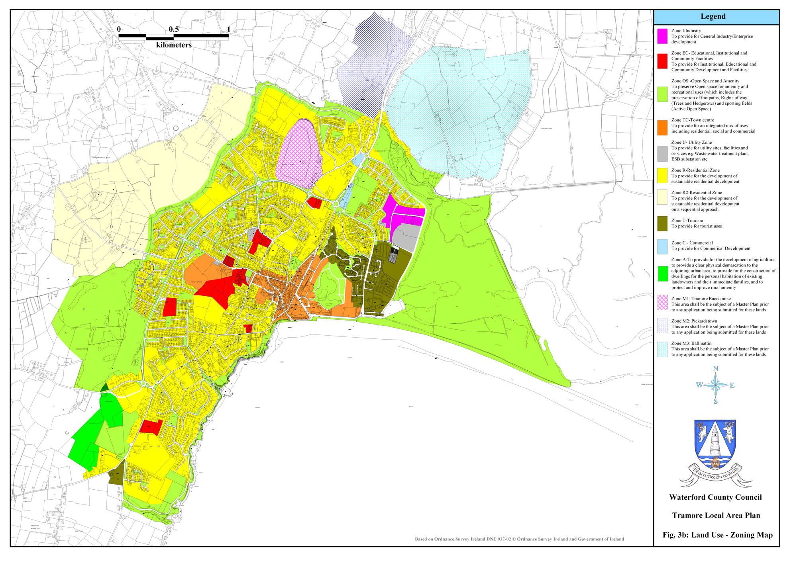

|  |  |  |  |  |  |
| --- | --- | --- | --- | --- | --- |
|  | Town centre |  | Utilities |  | Grass, fields |
|  | Residential |  | Public buildings |  | Tourist facilities |

Figure 3 shows the position of the school next to the main primary school and the boys secondary in the centre of the town (in red, indicated by the arrow), surrounded by it’s main catchment area. There are approximately 350 pupils and 30 staff at the school.

Data collection was primarily qualitative in nature. Interviews, focus groups and meetings were used to explore reasons for decisions made about mode of transport to school, what could be done to promote more active transport and reactions to the STP. Observations were made of pedestrian and car activity outside the school entrances and on the nearby roads at the morning, lunch-time and after-school pick up and drop off times. Questionnaires (multiple choice and open-ended questions) were used to determine mode of travel to school and the main benefits of and barriers to ATS. Three phases of data were collected: 1. baseline data – prior to the development and implantation of the STP; 2. impact data – two months after the implementation of the STP; 3. outcome data – five to six months after the implementation of the STP.

**Baseline results**

# Figure 4 shows that the Majority of pupils travelled to school by car. No one cycled. Distance from home to school ranged from 1.5km to 10 km, or a 5 - 30-minute walk. A Walkability Analysis (US Department of Transportation, 2008) of the surrounding routes to the school found discontinuous and missing footpaths in some areas, no pedestrian crossing on one extra-wide road, many cars and lots of dog mess on footpaths. Overall, however, there were pedestrian crossings at main junctions, plenty of footpaths and generally short distances from the main housing areas to the school. Tramore rated a respectable18 out of a potential 30 points.



Figure 4. Percentage modes of travel to school.

Three separate observations of the school entrances and near-by roads showed a congested and potentially dangerous situation for pupils. Figure 5 shows that cars were parked on both sides of the roads beside the school and directly in front of the school entrances, all of which are marked with double-yellow lines and/or yellow boxes; many had engines idling. Five students parked their cars here all day, obstructing the footpaths. Many cars stopped right in the middle of the road next to the entrances in order to drop off students.

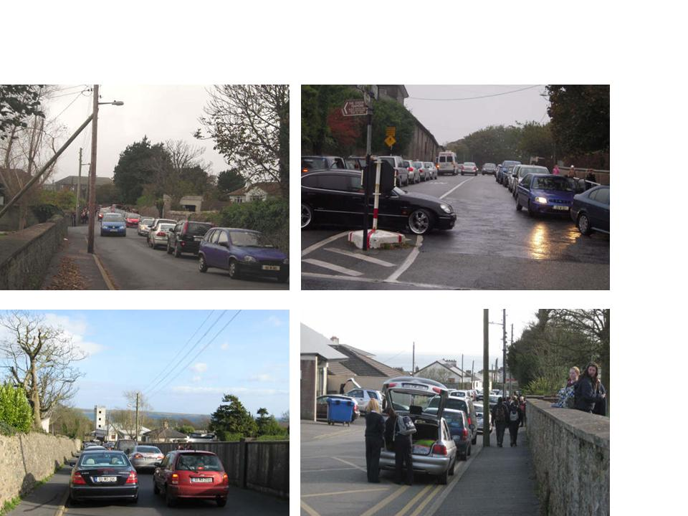

Figure 5. Congested school entrances and near-by roads.

An unexpectedly large number of students were picked up by their parents at lunch times and the student cars came and returned packed with other students. At the after school pick-up, pupils waiting in large numbers at school entrance and staff exiting the staff car park inside the school grounds often blocked each other’s view of the road. Congested parking by waiting parents blocked the road to such an extent that cars departing in a direction contrary to the majority could not pass, causing further traffic jams. Pupils leaving on foot had to share the footpath with parked and moving cars.

Student focus groups (with a total of 43) and questionnaires (115) identified many benefits of and barriers to ATS from students. Benefits were: exercise, fresh air, less traffic, less pollution, more social interaction and fun on the way to school, saves money, increases alertness in class, burns calories, keeps one in “good shape”, increases self-confidence, increases mental health, prevents obesity and finally creates independence. However these were generally out-weighted by the following commonly perceived barriers: journey problems, road safety and image, as illustrates by the following quotes

The journey

* “the journey is too long”; “it is too hilly”; “you’d be late for school so you’d have to get up to earlier”; “you often have to get to after-school activities quickly”; “school bags are often far too heavy to walk with”.

Road safety

* “there are large volumes of traffic and lots of speeding cars”; “the road by school is narrow and drivers don’t pay attention”; “there are no cycle lanes”.

Image

* “You can’t cycle to school in a skirt”; “skirts get wet/sweaty/dirty and catch in the wind”; “when girls walk to school their hair ends up bushy and messed up - boys don’t have to worry about that”; “Helmet hair, we couldn’t have that coming into school”; **“**You’d get laughed at if you cycle to school”.

Overall student’s attitudes to ATS were mixed. Many were positive about walking, particularly if the issues of heavy bags could be addressed. However, most were not interested in cycling to school and were actually very negative about an intervention or plan that might try to encourage and require them to do so.

Questionnaires from parents (n=78) and teachers (n=15) identified lighter school bags as key to encouraging ATS, traffic as a main deterrent, but concluded that many students simply do not want to walk to school. Parents were also concerned about excessive traffic and speeds, heavy school bags, the lack of pedestrian crossings. Their children apparently tell them that wheelie bags (bags with wheels) were ‘uncool’. Most stated that the commute to school was not associated with the commute to work. Neither parents or teachers believed walk/cycle groups would help encourage ATS. Both parents and teachers felt that it was parents responsibility to encourage and support ATS. In addition, the Parents’ Council thought that younger pupils might be more amenable to change, that cycling was more difficult mode to promote and might be better to do with boys.

Following these results and the consultation involved, we, the researchers and students involved in the green-schools committee, decided to focus on promoting walking, car pooling and park-and-stride (using a recommended drop-off point) to get to and from school. We chose not to promote, or event mention cycling in the STP because the reaction to questions about and/or discussion of cycling to school was so negative that both students and researchers felt that to include it would jeopardise the entire STP ATS-promotion project.

**The STP**

The STP was developed in conjunction with the eight-member student council during June and July 2008 and was informed by the baseline research. The draft plan was presented to all staff, students, parents and parent’s council during September for comment. Figure 6 shows the final version of the STP that was ‘launched’ in mid-October 2008 (the ‘kick off event’) in the local church car park before the start of school. A local radio station, aimed primarily at a younger audience, did a live broadcast on it’s breakfast show, and brought along it’s trendy Mini cars *(the irony was not lost on us?!!)* but the presenters did walk with the students to school that morning.

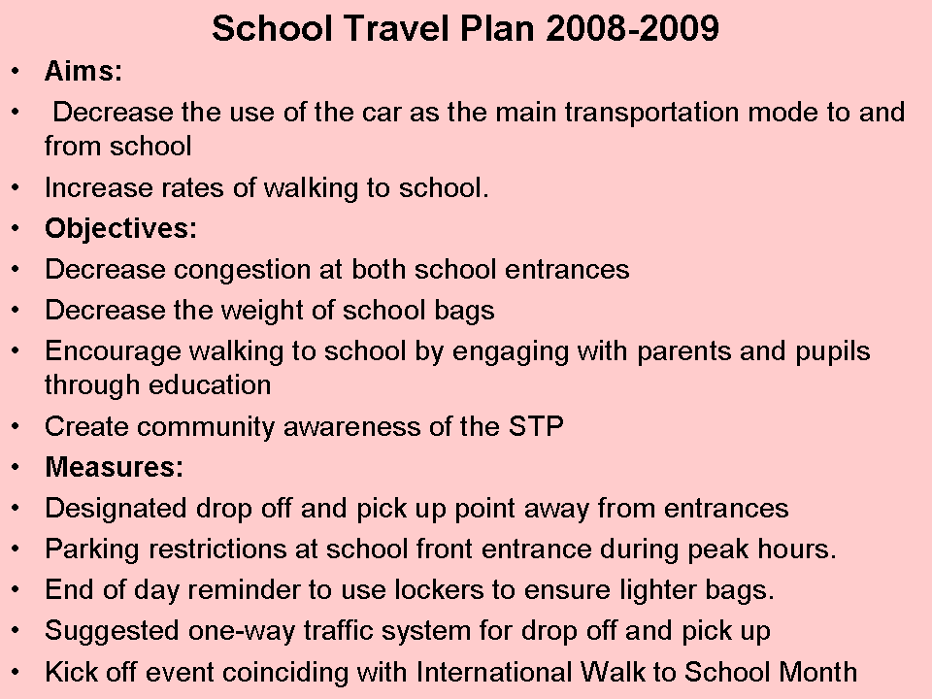

Figure 6. The Stella Maris School Travel Plan (STP)

Reaction from the students improved with decreasing age. One 6th year class was asked for a show of hands if they felt the plan was a good idea; no student appeared to support the plan and many commented on the difficulty of walking with heavy bags. First year pupils, on the other hand, were very excited about the idea of walking with their friends to school and especially looked forward to the kick-off event, some even suggested dress-up walk to school days.

**Impact of STP two months later**

Similar information to that gathered at baseline was collected from pupils, parents and teachers approximately two months after the launch of the STP, with the addition of questions about what had changed and why/why not. Only the latter is presented here.

The majority of pupils still travelled to school by car or bus and had made no change to their mode of transport to school since the launch of the STP. However, in questionnaires (26) some commented that they now shared a lift to cut down on traffic around the school, some had started walking on certain days of the week, many noticed an increase in the numbers walking to school, and many suggested that the STP had created greater awareness of walking to school. Regular observations had showed that the designated school drop-off point, the local church car park, was not being used as such by most parents. However, according to the students, other, informal drop-off points were being used instead (e.g., a local supermarket, bus-stop).

Teachers (7) believed that there was less congestion around the school at peak times, that it was easier to leave the school at 4 o’clock, and that there was a greater awareness of the possibility of walking to school. Half of all parents who returned completed questionnaires (26) said they had made no change in how they take their daughter to school, mainly for reasons of distance and fear of assault. The other half said that they were using other drop-off and pick-up points to allow their daughter to walk the remaining distance to school, were carpooling with neighbours, or were using the suggested one-way system around the school.

Students (44 returned questionnaires; 26 were part of focus groups) felt that need for lighter school bags was the one of the most important changes need to encourage more ATS. They also listed and discussed pedestrian crossings, traffic volumes, more and better quality footpaths, better bicycle parking, a coatroom, cycling lanes and better public transport as key factors. Teachers (7) listed the need for more and better quality footpaths, education of parents, better storage facilities for bicycles, a strategy to facilitate carrying schoolbags and an ongoing awareness campaign. Parents’ (26) main focus was on safety and traffic/road engineering. They identified the main junction leading to the school as a major safety issue because of the large peak hour traffic volumes of traffic, the lack of a pedestrian crossing and the situation of a bus stop. They also wanted more footpaths and some speed ramps, and believed that if local engineers witness the road/traffic problems they would be more inclined to help in their alleviation. They believed the parking restrictions were not beneficial to the promotion of walking to school and that the drop-off zones were unsuccessful.

**Outcome of STP six months later**

Only the information about what had changed and why/why not is presented here.

Although the majority of students who returned questionnaires (39) still travelled to school by car, they reported an 11% increase in walking and an awareness that more were walking to school. Informal drop-off points, other than outside the school entrances, continued to be popular, indicating that a majority were doing some form of ‘park-and-stride’ to school. Car-pooling remained popular. Teachers (4) also noticed less traffic congestion around the school at peak times and remarked that students appeared more aware of the benefits of ATS and more keen to do so. In focus group discussions students (27) revealed a concern about gangs, bullying and walking alone that had not been expressed before – this may be due to the increased numbers actually experiencing walking to or from school for the first time.

Parents (33) also reported changing their travel to school habits. Most reported using new drop-off and pick-up points, car-pooling, using the suggested one-way system and encouraging their daughters to walk home. Observations outside the school at pick-up and drop-off times found the school entrances and adjoining small roads were less congested when compared to baseline, pre-STP observations. However, many of those that dropped their daughters at the school continued to park on the double-yellow lines and yellow boxes outside the entrances. The issue of gangs and bullying was a concern that was not present at baseline. The Parent’s Council (12) and the school Principal were also concerned about the lack of bicycle parking facilities and the need for more pedestrian crossings.

**Conclusions**

This study explored attitudes of students, teachers and parents to walking and cycling school, with a particular focus on exploring the reasons why so few teenage girls in particular, cycle to school. All involved were well aware of the physical, social and mental benefits of walking and cycling to school and generally supportive of its promotion. Results show that before the STP most students were driven, some car-pooled, some walked, no-one used other drop-off points (park-and-stride) and no-one cycled to school. Six months later, the majority of students were either walking, car-pooling or using alternative drop-off/pick-up points (park-and-stride) to get to and from school.

Concerns or barriers to ATS expressed by students, parents and teachers were in line with those found in research world-wide: heavy traffic, speeding traffic, safety fears, lack of crossing places and footpaths, long walking distance, fear of crime and ‘gangs’ - the problem of heavy bags had not been identified in previous research. The results show that the transport infrastructure and design of the physical neighbourhood have a strong influence on young people’s levels of ATS and suggest that the way forward in promoting walking and cycling to school is the provision of tangible, infrastructural improvements (such as cycle lanes, more and wider footpaths, additional crossing points) and traffic restrictions (such as lowered speed limits and 1-way systems). However, in the end, increases in the numbers walking and using park-and-stride were seen without any change in the physical environment or in the provision of ‘facilities’. Indeed, research in Ireland by O’Driscoll (2005), mentioned previously, concluded that large packages of infrastructural measures as a means of promoting ATS were both expensive and premature.

It seems that young people’s (and their parent’s) first reaction when asked why they don’t walk or cycle to school more often, is to blame the tangible, physical environment (roads are too dangerous, too much traffic, etc.). Yet, the area around the school rated well on the Walkability Survey - there are adequate footpaths and pedestrian crossings on many of the routes to the school and the actual distances from homes to school (as opposed to those perceived) were generally short. Furthermore, parents were generating most of the traffic and poor driving that concerned them and their student children. They did not like, and generally ignored the restrictions placed on parking in front of the main school entrances, even though these were clearly designed to improve pedestrian safety. Also, the school provides lockers for all students so bags needed not be as heavy as they were reported to be.

Perhaps the primary focus on traffic and road dangers and heavy bags, should be seen as something obvious, concrete and plausible to ‘blame’ for the lack of a desired behaviour – all were well aware of the physical, mental and social benefits of ATS and supported the concept, yet most were driven to school. Therefore, the environmental barriers may present only small part of the picture but mask the role of other, more influential but less tangible, psycho-social factors – for example, further exploration of attitudes to ATS revealed that fears of embarrassment, looking silly and being sweaty while walking or cycling were the most important concerns for students. This will be discussed under the headings of social-traps, image concern and the onus of responsibility.

**Social-traps**

Carver, Timperio and Crawford (2008) highlight the pressures of the ‘social trap’ in which parents feel that in order to be seen as responsible parents they must conform with the practices of other parents who drive their children to school to ensure their safety. So they drive their children to school in order to protect them from the traffic danger they themselves are generating. However, a recent report UK parliamentary report (UK House of Commons, 2008, p.5) concluded that “cosseting children from traffic and depriving them of the opportunity to learn about risks and road skills is not a sensible or responsible approach. In many cases, this merely defers the danger to later in the child's life.“

Furthermore, as Mullan (2003) suggests, road safety concerns can heightened anxiety about strangers and ‘gangs’, which in turn may lead to more chauffering to school and other activities. This inevitably means fewer people being out and about on foot or bike in the neighbourhood, less familiarity with people living locally and increased fear of strangers and ‘gangs’. The subsequent increase in traffic volume accentuates road safety fears thus creating a ‘downward spiral of fear’ (Mullan, 2003) and reinforcing the ‘social-trap’.

**Image concerns**

The greatest barrier to ATS for the girls was their perceived image. ATS was seen as awkward, dangerous, requiring effort, creating hassle and sweat; not what ‘we see ourselves doing’; not for girls. Cars were seen as safer, more pleasant, less hassle, and didn’t ruin our ‘look’. Older students (4th-6th yrs), teachers and parents also generally saw ATS as being more suited to the younger students (1st and 2nd yrs), and parents felt that cycling in particular might be more suitable for boys. A general glance at the teen magazines in any newsagent shows that teenage girls today are under unprecedented pressure to conform to a look and mode of behaviour that requires dressing and grooming to appear sexy and grown up to boys and to each other, having a skinny body, and not doing anything physically exerting. Ironically, although ATS would keep possible weight gain in check, the potential for untidy hair, creased clothes and a flushed face (particularly from cycling) rules it out for them. The ‘approved’ way to achieve the skinny body is a low-calorie diet; the ‘approved’ way to come to school is by car or public transport.

Research commissioned by The UK Scottish Executive in 2001-2002 examined the reasons for the low levels of participation in physical activity by teenage girls (Scott Porter Research & Marketing, 2002). They found that teenage girls perceived it to be competitive, physically demanding and time consuming; that these negative perceptions were gained through direct experience within the school / PE context, the lack of appropriate media role models, low expectations of parents and general societal sexual stereotyping. They concluded that altering social expectations regarding ‘girls activities’ and the appropriateness of girls being very physical, changing the perception of physical activity as competitive and sport oriented and only for those who are good at it, and providing positive female role models, were essential to increase teenage girls’ participation in physical activity.

No girl cycled to school, before or after the study, and while this is likely to be the case in most girls secondary schools in Ireland, we have no objective research evidence. However, the Dublin-based ‘Take PART’ study (Nelson et al. 2008) found only that only one percent of girls (n=1930) involved in the study cycled while 9.4% of boys (n= 2083) did so. In this study, baseline survey and discussion found that attitudes cycling to school were so negative that a decision was made not to include cycling in the subsequent STP as it might put at risk the acceptance and engagement with the whole ATS project. In sum, girls’ desired image regarding their clothes and hair, and their concerns about feeling silly and embarrassed were completely anathema to cycling to school. SUSTRANS (SUStainable TRANSport), the main UK body for promoting cycling and walking, has also found image-related barriers to cycling to school among teenage girls. “The sorts of reasons that girls give for not wanting to cycle to school include; not wanting to be seen wearing a helmet, not wanting to “get messed up”, worrying that boys will laugh at them if they fall off, worrying that they will get hot and sweaty”. Their ‘Beauty and the Bike’ project is aimed a changing these attitudes to cycling. See [www.sustrans.org.uk/webfiles/Bike%20It/Beauty%20and%20the%20Bike%20Information%20Sheet.pdf](http://www.sustrans.org.uk/webfiles/Bike%20It/Beauty%20and%20the%20Bike%20Information%20Sheet.pdf) for more details.

Anecdotal evidence suggests that our image of a ‘cyclist’ is either of lycra-clad sporty types, earnest ‘save-the-planet’ types or new immigrants from eastern Europe who cannot yet afford a car. Regarding the latter, Ray D’Arcy, the Today FM presenter and enthusiastic cycle-commuter recalls people shouting after him while on his bike sentiments such as ‘do they not pay you enough in there?’; ‘could you not afford a car?’. This is clearly a residual feeling many parents and grandparents have from their days of having to walking to school in hail and gales and do not wish their children and grandchildren to have to do so. More profoundly, it also reflects the huge success of the car industry in marketing cars as lifestyle accessories and self-image enhancers that get you from A to B with speed, ease and style. Driving is promoted as an experience, a luxury, a destination in itself. In comparison, cycling and walking are mundane, unattractive and slow.

**Responsibility**

The initial support for the STP among all concerned and the recognition of the great benefits associated with ATS contrast strongly with the lower levels of support for its implementation. Through questionnaire responses and meetings parents aired their dislike of the parking restrictions around the school gates, yet one of the greatest fears about ATS was traffic accidents. Perhaps the plan seemed wonderful in theory and the reality of its implementation with the required car travel restrictions was less rosy. As adults we are car dependant and the all-pervasiveness of the car means that, while we comprehend the health-related arguments for traffic reduction, we do not accept the role or personal commitment to solving the problem (Hallsworth, Black & Toley, 1995). We have ‘no time’ to walk, have no economic incentives to do so (Owen, 1998) and feel little personal responsibility for congestion or pollution (Van Mugt, Van Lange & Meertens, 1996). Inevitably, we pass on these ‘message’ to young people, and, therefore, they typically have no wish to cycle or walk anywhere, alone or accompanied and look forward to the day when they too will be car owners. Indeed the kudos gained from driving to school is huge.

Harry McGee (2008) notes in a recent Irish Times article: “perhaps the biggest dissuader for cycling has been affluence: increasing wealth - and car ownership - has brought with it a culture of laziness. These days people cycle out of choice, not out of necessity: few seem to make that choice, especially when there are few compelling reasons to abandon the car. […] Safety and weather are factors in this, but so is indolence.”

**The future?**

The time is ripe for the promotion of ATS given the current economic, climatic, obesity and traffic congestion concerns. A cultural shift in our attitudes to cycling and car-dependency is needed. Our research shows that attitudinal and perception change is far more important than infrastructural changes, which can be prohibitively expensive. As is evident on visiting other countries where active transport is more common and ‘normal’, cycling and walking beget cycling and walking. The more young people and their parents see others cycling and walking to school the more they will consider it a viable option and have a go or encourage their children to do so. Thus the prevailing behavioural norms will change and the image-related threat and social-trap posed by ATS will gradually disappear.

Alexander, L.M., Inchley, J., Todd, J., Currie, D., Cooper, A.R., & Currie, C. (2005) The broader impact of walking to school among adolescents: seven day accelerometry based study. BMJ. Vol. 331, pp. 1061-1062.

Britain's National Children's Bureau 2003

Carlin, J.B., Stevenson, M.R., Roberts, I., Bennett, C.M., Gelman, A. & Nolan, T. (1997) Walking to school and traffic exposure in Australian children. Aust NZJ Public Health. Vol. 21, pp. 286-292.

Carver, A. Timperio, A. & Crawford, D. (2008). Playing it safe: The influence of neighbourhood safety on children’s physical activity - A review Health & Place, 14, 217–227.

Cervero, R. (1996) Mixed land-uses and commuting: Evidence from American Housing Survey. Transportation Research. Vol. 30, pp. 361-377.

Churchman, A., 2003. Is there a place for children in the city? Journal of Urban Design 8, 99–111

Cooper, R,, Page, A., Foster, L., Qahwaji, D. (2003). Commuting to School: Are Children Who Walk More Physically Active? Am J Prev Med 2003;25(4)

Davies, A. (Ed: 2003). *A Physically Active Life Through Everyday Transport with a Special Focus on Children and Older People and Examples and Approaches from Europe.* Copenhagen, WHO Europe

Davis, A., Jones, L., 1997. Whose neighbourhood? Whose quality of life? Developing a new agenda for children’s health in urban settings. Health Education Journal 56, 350–363

DiGuiseppi, C., Roberts, I., Li, L., 1997. Influence of changing travel patterns on child death rates from injury: trend analysis. British Medical Journal 314, 710–713.

Dixey, R., 1998. Improvements in child pedestrian safety: have they been gained at the expense ofother health goals. Health Education Journal 57, 60–69.

Duncan, M.J., Spence, J.C., Mummery, W.K., 2005. Perceived environment and physical activity: a meta-analysis of selected environmental characteristics. International Journal of Behavioural Nutrition and Physical Activity 2, 11.

Dublin Transport Office (2007). Travel to Education Survey. Dublin, DTO

Evenson, K.R., Huston, S.L., McMillen, B.J., Bors, P., & Ward, D.S. (2003) Statewide prevalence and correlate of walking and bicycling to school children. British Medical Journal (1998) Vol 316 pp. 1426-1428.

Frank, L.D. (2000). Land use and transportation interaction: implications on public health and quality of life. Journal of Planning Education Research. Vol 20 P. 6-22.

Frank, L.D., & Engelke, P.O. (2001) The built environment and human activity patterns: exploring the impacts of urban form on public health. Journal of Planning Literature. Vol 16, pp. 202-218.

Frank, L., Pivo, G. (1994) Impacts of mixed use and density on utilization of three modes of travel; single-occupant vehicle, transit, & walking. Transportation Research Records. Vol 1466. pp. 44-52.

Gordon-Larsen, P., Nelson, M.C., Page, P., Popkin, B.M., 2006. Inequality in the built environment underlies key health disparities in physical activity and obesity. Pediatrics 117, 417–424.

Galbraith J., Keegan, O. (2005). Attitudes of Cyclists and Car Commuters to Cycling in Dublin. VeloCity 2005 conference presentation. Retrieved from <http://home.connect.ie/dcc/docs/DublinCity/Attitudes.pdf> April 30th, 2009.

Hallsworth, A.G., Black, C.S., & Tolley, R.S. (1995) Psycho-social dimensions of public quiescence toward risk from traffic generated atmospheric pollution. Journal of Transport Geography. Vol. 3, pp. 39-51.

Handy, S. (1996). UNderstanding the link between the built environment and non-work travel behaviour. Journal of Planning Education Research. Vo 15 pp. 183-198.

Hillman, M. (Ed.), 1993. Children, Transport and the Quality Of Life. Policy Studies Institute, London.

Hillman M. (2000). The freedom and development of children and teenagers: more restrictions, more trouble ahead. SALSA, 6.

Hume, C., Salmon, J., & Ball. K. (2005) Children’s perceptions of their home and neighbourhood environments, and their association with objectively measured physical activity: a qualitative and quantitative study. Health Education Research. Vol. 20, No. 1, pp. 1-13.

Krahnstoever-Davison, K. and Lawson, C. (2006). Do attributes in the physical environment influence children's physical activity? A review of the literature. International Journal of Behavioral Nutrition and Physical Activity, 3, 19-29

Krizek, K.J., Birnbaum, A.S., Levinson, D.M., 2004. A schematic for focusing on youth in investigations of community design and physical activity. American Journal of Health Promotion 19, 33–38.

McGee, H. (2008) City cyclists get a rough deal Irish Times Saturday, November 8, 2008

Morris, J.M., Wang, F.S., Lilja, L. (2001) School children travel patterns – A look back and a way forward. 24th Australasian Transport Research Forum, Hobart: 2001.

Mullan, E. (2003). Young people’s perceptions of local traffic and car parking and its relationship to their opinion of the safety, sociability and quality of their local area. *Health and Place, 9,* 351-360

Nelson, N., Foley, E. O'Gorman, D. Moyna, N. & Woods, C. (2008). Active commuting to school: How far is too far? International Journal of Behavioral Nutrition and Physical Activity, 5 (1). Retrieved from [www.ijbnpa.org/content/5/1/1 25/04/09](http://www.ijbnpa.org/content/5/1/1%2025/04/09)

O'Driscoll F. (2005) Safer routes to school: next steps. Dublin Transportation Office.

Roberts, I., Carlin, J., Bennett, C., Bergstrom, E, et al. (1997). An International study of the exposure of children to traffic. Injury Prevention, 3, 89-93.

Scott Porter Research & Marketing Ltd. (2002) *An exploration of issues and attitudes surrounding the low levels of participation in physical activity amongst:1. Parents of pre-fives children, 2. Teenage girls, 3. Men in mid years*. Edinburgh, Scottish Executive

Saelens, B.E., Sallis, J.F., Black, J.B., Chen, D., 2003. Neighborhood- based differences in physical activity: an environmental scale evaluation. American Journal of Public Health 93, 1552–1558.

Saelens, B.E., Sallis, J.F., & Frank, L.D. (2003) Environmental correlates of walking and cycling: finding from transportation, urban design, and planning literatures. Annals of Behavioural Medicine, 25, 80-91.

Sirard, J.R., Ainsworth, B.E., McIver, K.L., & Pate, R.R. (2005) Prevalence of active commuting at urban and suburban elementary schools in Columbia, S.C. American Journal of Public Health. Vol. 95, pp. 236-240.

Sustrans (1996). Safety on the streets for children. Bristol, Sustrans.

Timperio, A., Crawford, D., Telford, A., Salmon, J., 2004. Perceptions about the local neighborhood and walking and cycling among children. Preventive Medicine 38, 39–47.

Timperio, A., Ball, K., Salmon, J. Roberts, R., Giles-Corti, B., Simmons, D., Baur, L. and Crawford, D. (2006). Personal, family, social, and environmental correlates of active commuting to school. American Journal of Preventive Medicine, 30(1), 45–51

Tudor-Locke, C., Ainsworth, B.E., & Popkin, B.M. (2001) Active commuting to school: an overlooked source of children’s physical activity? Journal of Sports Medicine. Vol. 31, pp. 629-633.

TRB/IOM (Transportation Research Board and Institute of Medicine of the National Academies), 2005. Does the built environment influence physical activity? Examining the evidence TRB Special Report 282, National Academy Press, Washington, DC.

UK House of Commons, Select Committee on Transport: Eleventh Report (2008). Retrieved from

www.publications.parliament.uk/pa/cm200708/cmselect/cmtran/460/46005.htm#note106

Dec 15th, 2008.

US Department of Transportation (2008). Walkability Analysis, Retrieved from [www.walktoschool.org/downloads/checklist-walkability.pdf October 2008](http://www.walktoschool.org/downloads/checklist-walkability.pdf%20October%202008).

Van Mugt, M., Van Lange, P.A.M., & Meertens, R.M. (1996) Commuting by car or public transportation? A social dilemma analysis of travel mode judgements. European Journal of Social Psychology. Vol. 26, pp.373-395.

Vanderbeck, R. and Johnson, J., (2000) “That’s the only place where you can hang out”: urban young people and the space of the mall. Urban Geography. 21(1), 5-25.