ANALYSIS OF THE EFFECTS OF FIBRE SURFACE MODIFICATION OF ARAMID FIBRES IN A THERMOPLASTIC MATRIX

Austin B. Coffey, Waterford Institute of Technology, Ireland

Abstract
Aramid fibers were subjected to a variety of surface treatments to improve the interfacial stress transfer between a thermoplastic matrix and the treated fiber composite. Analytical techniques to characterize the effect of surface treatment included DSC, Optical Microscopy, AFM and micromechanical analysis using Raman spectroscopy. Correlations between the different analysis methods were identified. It was found that plasma modified and chloride grafted fibers had the largest degrees of transcrystallinity, highest nucleation rates and greatest interfacial shear strength between fiber and matrix.

Introduction
It is well known that the mechanical properties of fiber-reinforced composites are highly dependent on the interactions between the fiber and the matrix. The primary role of the interface in composites is to transfer the load from the matrix to the fibers. To take full advantage of the mechanical properties of the fiber and matrix, the interfacial shear strength between the fiber and matrix must be greater than the failure shear strength of the matrix or of the fiber. Several mechanisms that contribute to adhesion have been identified, namely, mechanical, physical interaction, and chemical bonding at the fiber–matrix interface.
Due to the poor adhesion between aramid fibers and most matrices, aramid fiber-reinforced composites are characterized by relatively low off-axis properties [1]. This limitation is further aggravated by the skin–core morphology and the weaker skin properties of aramid fibers. In fact, it was observed that aramid–epoxy interfacial failure involves failure by fibrillation at the fiber outer surface, which suggests the presence of a cohesive weak layer on the fiber exterior that can fail at low shear levels, resulting in low values of interfacial shear strength and, consequently, insufficient fiber–matrix load transfer [2]. In order to improve the interfacial bonding between the aramid fiber and polymer matrix, a variety of fiber surface modifications have been attempted, including grafting, use of coatings, chemical attack of hydrogen amide groups, and the formation of functionalities by plasma treatment.

Limited publications exist on the interaction between aramid fibers and thermoplastic elastomeric interfaces. This paper addresses methods for optimization of the interface to enhance stress transfer between a thermoplastic elastomer matrix material and an aramid fiber. This was achieved by using a number of fiber surface modification techniques.

A wide range of analytical techniques were used to analyze the effects of the fiber surface modification on the performance of the composites. Average maximum interfacial shear strength values greater than the maximum shear strength of the matrix were found to exist for some surface modified fiber composites. This was due to the presence of an interphase called the transcrystalline region which had greater mechanical properties than that of the matrix bulk material.

Experimental

Materials
The fiber used in this study was Twaron 2200 a poly(p-phenylene terephthalamide) (PPTA) aramid fiber, supplied by Akzo Nobel Research (Arnhem). The fibers have modulus Ef = 136 GPa, tensile strength, σ*f = 3.6 GPa and a failure strain ε*f = 2.6%. The diameter of the fiber was 12.1 ± 0.5 μm. The matrix used was a thermoplastic elastomer, polyether amide block co-polymer supplied by Atofina known commercially as ‘Pebax’. These thermoplastic elastomers (TPE) consist of linear chains of hard polyamide (PA) blocks covalently linked to soft polyether (PE) blocks via ester groups. The grade of Pebax used was Pebax 7033, with a modulus Em = 128 MPa, yield stress σy = 32 MPa, Yield strain εy = 25 %, ultimate failure stress σ* m = 67 MPa and an ultimate strain ε*m = 400 %.

Fiber Surface Treatments
The fibers used in this study were subjected to a variety of surface treatments in order to attempt to improve the interfacial stress transfer between matrix and fiber. Details of the various surface treatments are given in Table 1. Chloride end-groups were grafted to the Twaron 2200 fibers using a variation of the method proposed by Andreopoulos [1]. Plasma treatment was also carried out using a PS1010 plasma reactor from 4th State Inc., USA. The plasma was generated by a 150 kHz capacitively coupled discharge in a cylindrical chamber using a reactor power of 10 W, a pressure of 0.25 torr, and a gas flow rate of 20 standard cm3 min-1. The Twaron 2200 PPTA fibers were treated with argon (Plasma 1), nitrogen (Plasma 3) and ammonia / nitrogen (Plasma 4). N-vinyl-2-pyrollidinone (NVP) was grafted onto the aramid fiber surface using a photopolymerising procedure. The extent of polymerization was controlled by varying the irradiation time. The UV lamp used was a Philips HPM15 (2 kW) at a distance of 15 cm from the sample. Benzophenone (Sigma Aldrich) was used as an initiator (hydrogen abstractor), and Irgacure 184 (Ciba Speciality Chemicals) was used as a cross-linking agent.

Coupling agents and adhesion promoters represent a group of speciality bifunctional compounds that can react chemically with both the substrate and the adhesive Organometallic coupling agents based on zirconium or titanium have been shown to offer a wider compatibility with aramid fiber than the more widely used organosilanes [10]. Lica 44 ((neopentyl(diallyl)oxy, tri(N-ethy1enediamino)ethyl titanate) and NZ97 (neopentyl(diallyl)oxy, tri(m-amino)phenyl zirconate) from Kenrich Petrochemicals Inc., USA were used as the coupling agents. About 1 % w/w of the coupling agent was added to a solution of HPLC grade methyl pyrollidinone and aramid fibers were added. The fibers were soaked for 18 hours then washed with solvent and dried in an air circulating oven at 80°C for 2 hours.

Equipment
A Renishaw 1000 Raman imaging microscope was used to record the spectra of the fiber monofilaments using the near IR 785 nm red line of a diode laser. A 50X objective lens of an Olympus BH-2 optical microscope was used to focus the laser beam on the specimen surface (spot size ~ 2 μm diameter) and to collect 180° back-scattered radiation. A highly-sensitive Renishaw charge–coupled device (CCD) camera was used to collect the Raman spectra. The degree of peak shift and peak broadening under stress of the 1610 cm-1 PPTA Raman band, corresponding to the vibration of the backbone p–phenylene ring [6] were determined.

DSC experiments were conducted using a Perkin-Elmer DSC 6. For general DSC ramp traces, a heating and cooling rate of 10°C/min was used, with an equilibrating time of at least two minutes at each ramp change. All samples at the start of a cycle were maintained at 200°C for 5 minutes to completely melt the Pebax 7033 polymer and erase any previous thermal history. For the isothermal crystallinity kinetic measurements, the samples were cooled at 100°C/min to a pre-defined crystallization temperature. The sample was maintained at the crystallization temperature until the signal was flat, indicating that crystallization was complete.
The optical analysis of the interphase between the fiber and matrix conducted using a polarizing optical microscope (Olympus U_LBD_2 with Omnimet photo program).

Results and Discussion
Using optical microscopy and AFM, it was noticed that an interphase region existed between the fiber and matrix. Figure 1 presents an example of this region, known as a transcrystalline region for a succinyl chloride treated fiber embedded in a Pebax 7033 matrix. The influence of the fiber sizing on the mean thickness of the transcrystalline (TC) layer is shown in Figure 2. It is obvious that the TC layer is sizing specific. All samples were studied for the effect of sizing on the TC degree by using identical preparation methods and thermal processing.
Using optical microscopy, high degrees of TC were identified – up to three times the fiber diameter. The largest degrees of TC occurred for the chloride modified surfaces. For the non-treated fiber surface, the TC layer thickness was measured to be 22 ±3 μm, while that for the methacryloyl and suberoyl chloride treated fibers were 34.5±2 μm, and 35±3 μm respectively, which amounted to over 37% increase in TC thickness. NVP treated fibers showed a transcrystalline layer thickness of 26 ± 4 μm. It is noted that for the succinyl chloride treated fiber example, the TC surrounding the fiber exhibits a bi-layered structure comprising of a compact inner layer, clearly seen in Figure 1 and a more open outer layer where the outer layer exhibits radial orientation of columnar spherulites nucleated on the edge of the inner layer.

Evidence of transcrystallinity can clearly be seen from the AFM scans shown in Figure 3 and the transcrystalline regions are marked with the aid of arrows. In the region of the fibers, single planes of crystal growth exist, while outside of this interfacial region, clear spherulitic structures occur. Under the phase imaging contrast pictures (left hand sides), alongside the fibers, the crystalline fibrils are perpendicular to the fiber axis which shows evidence of a transcrystalline region.
It is shown that the level of transcrystallinity is dependent on the fiber surface modification. To decipher whether these levels of transcrystallinity had a major influence on the bulk crystallinity of aramid – Pebax composites, DSC analysis was used.

In Figure 4 the half-time (τ_{1/2} ) for Pebax 7033 composites’ crystallization at different crystallization temperatures is shown as derived from the crystallization kinetics for the composite materials presented in Table 2. Plotting half-time crystallization as a function of crystallization temperature is a method for assessing the time required for crystal growth conversion. It is seen that the PPTA AS fiber composites had a decrease in the half-time for the crystallization from that of the virgin Pebax. This trend is attributed to a nucleating effect of the aramid fibers on the Pebax 7033 crystallization. It was found from the optical microscopy transcrystallization studies, that the largest amount of transcrystallization occurred for the succinyl chloride treated PPTA Pebax 7033 composites. The half time of crystallization also showed that the succinyl treated PPTA fibers gave the highest degree of nucleation. The values of τ_{1/2} depend on the crystallization temperature and the composite composition in terms of fiber surface treatment. In all cases as expected, τ_{1/2} increases with temperature since there is increased energy in the system for crystallization to occur. The lower τ_{1/2} at higher temperatures means that the nucleation has improved.

The Avrami growth rates, Z, (Figure 5) are much faster for the chloride treated PPTA fibers than the rest of the treated fibers. It is noted that the growth rate for the Pebax 7033 virgin material is comparable to that of the PPTA AS composites, along with the Plasma 1 and Plasma 4 treated PPTA fiber composites. NVP treated fibers are significantly lower than the control samples. The levels of transcrystallinity shown in Figure 2 are somewhat consistent with these results (apart from NVP treated fibers) such that the largest growth rate corresponded to the highest level of transcrystallinity. Again, it seems that the NVP treated PPTA fibers retard the nucleation process. The low nucleation rate for the NVP treated PPTA fiber composites reinforces the findings from the extrapolated onset-temperature of crystallization results shown in Table 2. However, in the case of the NVP treated fibers, retardation of the crystallization process was most likely caused by the steric effects of the large NVP molecule.

The composite samples used for the thermal analysis investigation all had a similar fiber volume fraction. All the experimental conditions for the thermal analysis response for the samples were constant. The only main variation between the samples was the different fiber surface treatments used. Avella et al [3] found that the growth rate and the melting temperature of the transcrystalline phase was found to equal those of bulk-nucleated samples. It can be thus confirmed that the higher nucleation results for the chloride treated PPTA composites (and argon plasma treated composites) means that these treated fibers promote the growth of a transcrystalline layer. This is seen from the lower Avrami growth rates, the lower half-time required for Pebax crystallization, and the higher degrees of transcrystallization observed from optical microscopy.

The use of Raman spectroscopy to map the stress and strain characteristics of an embedded fiber in a polymer matrix has been investigated by many authors [5-9].

The estimated shear yield stress of Pebax 7033 was 16 MPa. However, this does not explain the reason why for some samples such as the Plasma treatment and NVP treated PPTA single fiber composite samples yielded a higher ISS than the shear stress of the material. The calculated values of the maximum ISS are the average maximum ISS values along the fiber (fragment) length and not those solely taken at the fiber ends. These ISS values were repeatable to ± 2MPa.

For the Plasma 1 treatment, the interphase region in which there is an improved ISS is probably due to improved surface contact area of the Plasma 1 (argon) treatment. Since inert gases such as argon exist in their monatomic state, their reaction with the fiber surface is a kinetic energy transfer, or in simple terms, a molecular scale sand blast. Thus the possibility of any contaminants on the fiber surface would be diminished, thus improving any potential interface with a matrix material.

For the NVP treated fibers, increased hydrogen bonding with the polyamide component of the Pebax matrix could have resulted. This may especially be the case from the cooling of the Pebax melt in which the NVP may have been oriented to couple with the PA segment of the Pebax and thus initiate hydrogen bonding. This argument is plausible, but is not supported from the crystallization studies, probably due to the large size of the NVP molecule accounting for some steric hindrance. However, Huang and Petermann [4] suggested that steric hindrance was a key factor in the development of transcrystalline regions. This could be the case here, where an increased transcrystalline region formed around the fiber, and thus attributed to improved interfacial properties.

Thus, it is feasible to suggest that in this localized interphase region, there is potential for a higher ISS than the yield stress of the matrix material. However, the ISS results generated in this work do not deviate from the shear yield stress of the matrix material to the same degree as in the work from Melanitis and Galiotis [9]. The high ISS found by Melatitis and Galiotis was possibly due to the method by which they derived the ISS from the strain profiles. Similar to the procedure used in this thesis, and the methods incorporated by Young et al [5-8]. Melatitis et al used a balance of forces argument to calculate the ISS from the fiber strain (or stress) profiles.
However, this does not explain the reason why for some samples such as the Plasma treatment and NVP treated PPTA single fiber composite samples yielded a higher ISS than the shear stress of the material. The calculated values of the maximum ISS are the average maximum ISS values along the fiber (fragment) length and not those solely taken at the fiber ends. These ISS values were repeatable to ± 2MPa.
Melanitis and Galiotis [9] reported from their Raman experiments on a fragmented carbon fiber that the ISS can be higher than the shear yield stress of the neat matrix. They reported an ISS of 66 MPa, whereas the shear yield stress of the neat matrix (in this case epoxy) was 35 MPa. They explained this disagreement by use of the interphase concept as proposed by several researchers [10, 11]. The interphase is a region close to the fiber/matrix interface in which it is assumed that the morphological composition of the matrix is different from that of the bulk matrix [12]. Consequently the interphase has mechanical properties different from the bulk. This argument is quite plausible considering the evidence of varying levels of transcrystallinity occurring in the vicinity of the fiber which are also dependent on the type of fiber surface modification. It would also explain the reason why the Plasma, chloride treated and NVP treated fibers have an ISS which was greater than the shear strength of the Pebax 7033 matrix, which can be manifested as a level of improved adhesion.
For the Plasma 1 treatment, the interphase region in which there is an improved ISS is probably due to improved surface contact area of the Plasma 1 (argon) treatment. Since inert gases such as argon exist in their monatomic state, their reaction with the fiber surface is a kinetic energy transfer, or in simple terms, a molecular scale sand blast. Thus the possibility of any contaminants on the fiber surface would be diminished, thus improving any potential interface with a matrix material.
For the NVP treated fibers, increased hydrogen bonding with the polyamide component of the Pebax matrix could have resulted. This may especially be the case from the cooling of the Pebax melt in which the NVP may have been oriented to couple with the PA segment of the Pebax and thus initiate hydrogen bonding. This argument is plausible, but is not supported from the crystallization studies, probably due to the large size of the NVP molecule accounting for some steric hindrance. However, as already suggested, steric hindrance can be a key factor in the development of transcrystalline regions and thereby improving the interfacial properties.
These fiber treatments for Aramid fibers in a thermoplastic matrix such as Pebax 7033 can be used in a wide variety of applications, not solely the medical device industry. Accurate theoretical prediction of the mechanical response of a reinforced structure can be a major cost saving measure in the validation of conceptual designs. This can have positive ramifications in reducing time to market, supporting design history files, and product development savings.
SUMMARY
It has been shown that varying surface treatments for an aramid fiber in a Pebax 7033 matrix keeping all other parameters constant will affect the degree of transcrystallinity. The degree of transcrystallinity observed can be observed using optical microscopy and correlated to the crystallization kinetics. Fiber surface modification showed improvements in increasing the effectiveness of in the interfacial properties, especially in terms of reducing the critical fiber fragment length, which is a measure of good interfacial properties from the classical fragmentation micromechanics theory. Improvements in the interface between fiber and matrix were quantitatively found using Raman spectroscopy, and there appears to be some broad qualitative relationship between the degree of transcrystallinity and the interfacial properties of the composite – however further studies are required.

ACKNOWLEDGEMENTS
The author wishes to acknowledge the financial support received through the Higher Education Authority Program for Research in Third Level Institutions, and the technical support of the National Centre for Biomedical Engineering Science, NUI, Galway, Ireland, and Polymer Research Dept., Athlone Institute of Technology, Ireland, and Prof. RJ Young, University of Manchester, UK.

Key Words: Aramid, Pebax, Interface, Surface Modification, Raman spectroscopy, Interfacial Shear Strength.

References
- Tarantill PA., Adreopoulos, J. Appl Polym Sci., 65, 267-276 (1998)
- J. Kalantar and L. T. Drzal, J. Mater. Sci., 25, 4186 (1990).
- M. Avella, G.D. Volpe, E. Martuscelli, M. Raimo, Polymer Engineering and Science, 32, 376, 1992.
- Huang Y, Petermann J., J. Appl. Polym Sci, 55 (7) 981-987 (1995)
- Van den Heuvel PWJ, Peijs T, Young RJ., J Mat Sci Lett, 1996, 15 1908
- Van den Heuvel PWJ, Peijs T, Young RJ, J. Compos Sci. Technol 1997; 57, 899
- Van den Heuvel PWJ, Peijs T, Young RJ J. Compos Sci. Technol 1998, 58, 933
- Van den Heuvel PWJ, Peijs T, Young RJ, Composites Part A, 31, (2000) 165-171
- Melanitis N, Galiotis C, Proc Royal Soc. London A, 1993, 440A, 379
- Jayaraman K, Reifsnider KL, Swain RE, J. Compos Technol Res., 1993, 15, 3
- Williams JG, Donnellan ME, James MR, Morris WL, Mat Res Soc Symp Proc 1990, 170, 285
- Herrera-Franco PJ, Drzal LT., Composites, 23 (1992), 2 – 27
Table 1 Description of methods of surface modification of Twaron 2200 fibers
Fibre Surface Modification | ABBREVIATION
No surface modification | AS
Methacryloyl chloride treated aramid fiber | MC
Succinyl chloride treated aramid fiber | SC
Acrylic acid treated aramid fibre | AA
NVP (Benzophenone + Irgacure 184 + UV) treated aramid fiber | NVP
Argon Plasma treated aramid fiber | P1
Oxygen Plasma treated aramid fiber | P2
Nitrogen Plasma treated aramid fiber | P3
Ammonia / Nitrogen Plasma treated aramid fiber | P4
Titanate coupling agent, Lica 44 treated aramid fiber | Li44
Zirconate coupling agent NZ 97 treated aramid fiber | NZ97

Table 2 Data collected from Thermal Analysis of composite materials where Δ H is the transition heat of melting or crystallization, Tm, Tc,m are temperatures of maximum of melting or crystallization peak or shoulder, and Tc,o is the extrapolated onset-temperature of dynamical crystallization. Activation energy is calculated from the isothermal crystallization studies
Material | Cooling @ 20K/min |  |  | Heating (after cooling @ 20K/min) |  |  |  | Activation Energy (E_{a})
 | Δ H (J/g) | T_{c, m} (°C) | T_{c, o}(°C) |  | Δ H (J/g) | Tm(°C)
PPTA-AS | 43.2 | 137.1 | 147.0 |  | 32.35 | 173.32 |  | 384±157
Plasma 1 | 42.3 | 138.4 | 148.7 |  | 38.45 | 171.12 |  | 494±66
Plasma 3 | 46.6 | 136.7 | 148.0 |  | 44.09 | 170.97 |  | 386±374
Plasma 4 | 47.4 | 137.8 | 147.5 |  | 43.46 | 170.54 |  | 362.4±25
NVP | 27.3 | 136.5 | 146.0 |  | 20.62 | 175.18 |  | 303±342
Pell | 32.2 | 136.6 | 146.0 |  | 24.65 | 172.21 |  | 4±304
Succinyl Chloride | 42.3 | 138.5 | 151.5 |  | 42.25 | 172.41 |  | 401±20.6
Lica 44 | 51.5 | 136.3 | 146.0 |  | 40.03 | 171.72 |  | 375±58
Lica 97 | 43.7 | 135.3 | 146.0 |  | 49.97 | 168.08 |  | 257±51
NZ 97 | 41.2 | 135.9 | 146.3 |  | 42.73 | 170.01 |  | 177±79
Pebax Virgin | 46.1 | 139.5 | 148.0 |  | 37.02 | 172.26 |  | 332±134

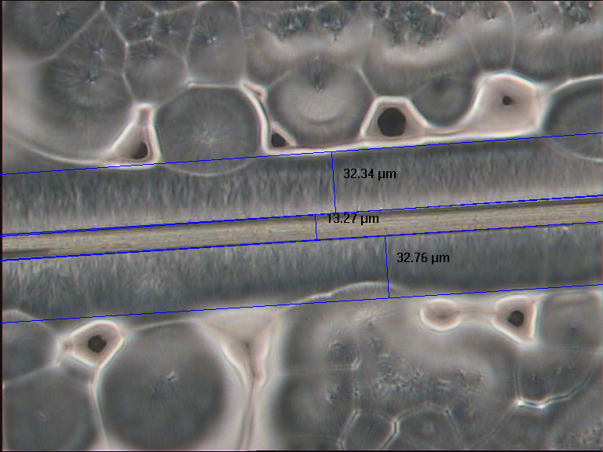
Pebax

Aramid
Transcrystalline Layer

Spherulites

Figure 1 Example of the transcrystalline layer formed around an aramid fiber (Succinyl Chloride) embedded in a Pebax matrix.

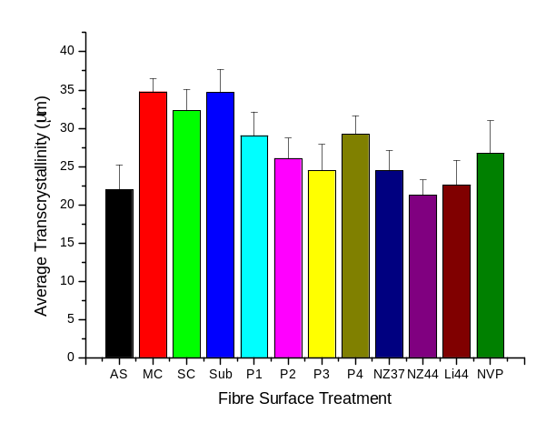
Figure 2 Graph shows the sizes of the transcrystalline zones formed around aramid fibers embedded in a Pebax matrix. The fibers have varying surface treatments

Transcrystalline Region

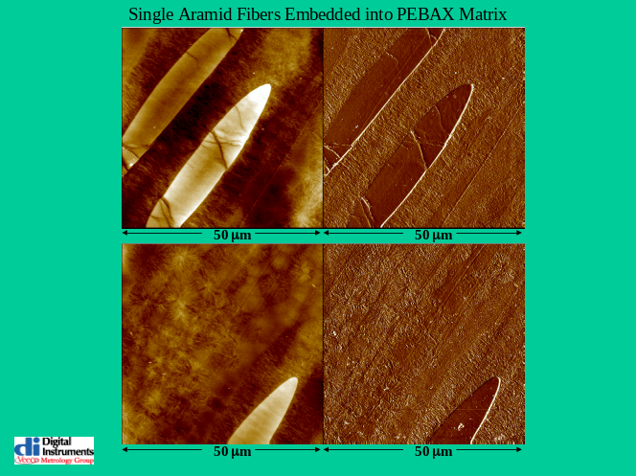
Spherulitic
Region

Figure 3 Tapping Mode AFM micrograph of PPTA AS Pebax composite cryogenically ultramicrotomed at different areas of the section. The LHS pictures are of the z-piezo height and RHS is the phase image micrograph.
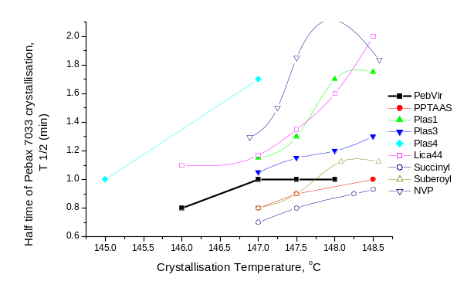
Figure 4 Half-Time of Pebax 7033 PPTA composites’ crystallization as a function of crystallization temperature. Selected samples are subjected to various surface treatments.

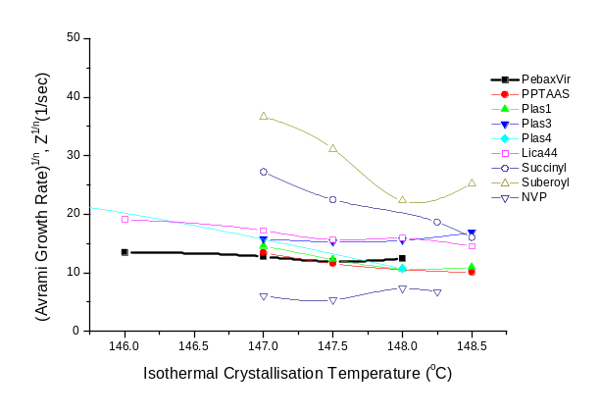
Figure 5 Avrami growth rate, Z, calculated from the best fit of the Avrami equation to the experimental data. Z^{1/n} is presented rather than Z to force unit consistency; unit consistency is necessary to compare values calculated with different n values
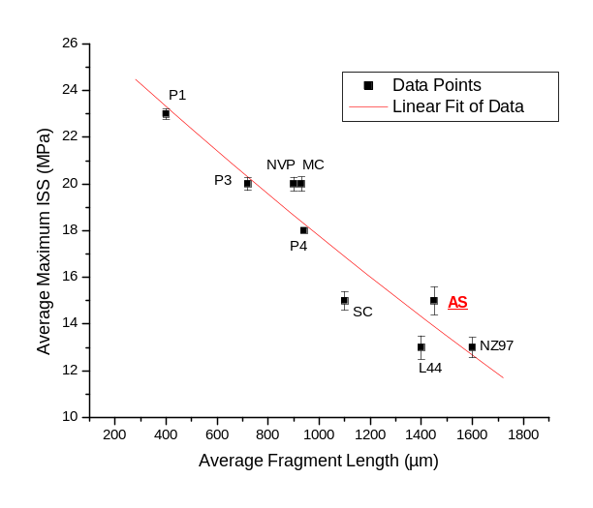Figure 6 Average Max. ISS v. Average Fragment Length for aramid fiber with various surface treatments with a Pebax 7033 matrix

